Chemistry I-Standard
Chemical Bonding Lecture Notes

In the previous unit, we got a preview of what happens when atoms combine together to form a new substance: a compound. In this unit, we seek to understand the chemical properties of these new substances through characterizing what is happening in the bond, drawing its structure, and observing the shape of the molecule. From this understanding, we will then be able to study it polarity and how this overall molecular polarity will contribute to the forces that hold the molecules (not just its bonds) together.

I. │ Review of Chemical Bonds & Classifying Different Bond Types

Type of Bond | Interaction between…. | Formation of bond due to… | Phase at room temp. | Electrical Conductivity | Solubility in water
Ionic
Covalent
Metallic

- Each element has its own electronegativity value. We’ve studied this idea before, but only conceptually. Now we can apply simple math to understand it further. Below is a periodic table of these values:
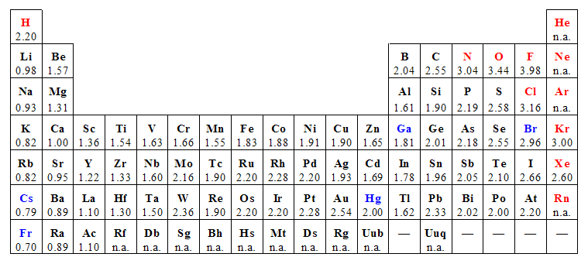
- Classifying the different types of bonds with the Pauling Electronegativity Scale.

- Using the above scale and electronegativity values, predict the types of bonds (this is also called the bond polarity) of the following pairs of atoms:

H-H ____________ H-Cl ____________ S-O _____________

Li-N ____________ K-F ____________ Ca-P ____________

Na-Xe __________ O-O ____________ Mg-O ____________
-2-

II. │ Structure of Covalent Molecules: Drawing Lewis Structures

- A Lewis structure (named after the chemist G.N. Lewis) is a two-dimensional representation of the real three-dimensional substance.

- Steps for drawing Lewis structures:
- Determine the chemical formula for the substance.
- Add up the total number of valence electrons for all elements. These must all be used.
- Determine which at is the central atom.
- Oftentimes the element written first in the formula is the central atom.
- The least electronegative atom is the central atom.
- If carbon is present it is always the central atom.
- If hydrogen is present, it is NEVER the central atom.
- Draw the symbols for the elements and connect them by single bonds. A single bond represents two electrons.
- Once all atoms are connected by single bonds, complete the octet of every atom with lone pair electrons.
- If all the valence electrons are used and the octet configuration is not achieved (is lacking electrons), then one or more multiple bonds must exist. For every two electrons that are needed that do not exist, a multiple bond is needed. If four electrons are needed, either two double bonds may be needed, or a triple bond may be needed.

Sample Exercises:

1. CF₄ Total VEs: ______ | 2. NH₃ Total VEs: ________ | 3. water Total VEs: ________
4. carbon dioxide Total VEs: ____ | 5. nitrogen gas Total VEs: ____ | 6. sulfur dioxide Total VEs: ____
-3-

III. │ Valence-Shell Electron-Pair Repulsion (VSEPR) Theory

- VSEPR Theory is the theory Chemists use to describe the molecular shape (or geometry) of a molecule.

- Main Idea: the valence electrons in a molecule are the electrons which participate in bonding and these electrons are repelled by each other. The molecule will adopt a certain shape to minimize these electron repulsions as much as possible.

- In order to determine the molecular shape, a valid Lewis structure must be drawn first!

Table of Molecular Shapes:

A = central atom X = atom attached to CA (also known as external atom) E = lone pair electron

General Formula | Lewis Structure | # of bonding groups (on CA) | # of lone pairs electrons (on CA) | Molecular Shape | Bond Angle
AX₂
AX₂E
AX₂E₂
AX₃
AX₃E
AX₄
-4-

IV. │ Molecular Polarity & Intermolecular Forces (IMFs)

- Molecular polarity: how polar a molecule is overall. Different than bond polarity.
- Determining Molecular Polarity:
- No lone pairs on central atom = Nonpolar
- Lone pairs on central atom = polar
- The forces that hold molecules together – molecules are not just floating around by themselves as individual molecules. They are attracted to one another.
- Present in all substances but dominant in covalent molecules.
- Are weaker than intramolecular forces (bonds)
- An intramolecular force holds H & O atoms together within a molecule. An intermolecular force holds water molecules together.

Table of Intermolecular Forces:
IMF | Properties | Picture
Dispersion Forces | - A.K.A. Van Der Waals or London  - Temporary attraction  - Weak attraction between the opposite ends of different molecules.  - Weakest of all IMFs  - dominant in non-polar molecules but occurs between all. | 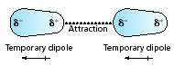
Dipole-Dipole | - Permanent dipoles (some regions of a polar molecule are always partially negative & some regions are always partially positive)  - Attraction between polar molecules.  - Stronger than London Dispersion Forces. | 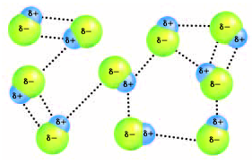
Hydrogen (bonding) interactions | - Occurs between molecules containing hydrogen atoms bonded to either F, O, or N atoms  - Strongest IMF | 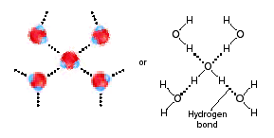

Steps for determining the Molecular Polarity and Intermolecular Force (IMF)
- Draw the Lewis structure for the molecule
- Look at the center atom:
  - No lone pair (nonbonding electrons) on center atom = the substance is nonpolar and has London Dispersion forces
  - 1-2 pairs of nonbonding electrons on the center atom = the substance is polar and has Dipole-Dipole forces. EXCEPTION: If H is bonded to N, O, or F, then it’s a Hydrogen interaction.

Macromolecules and network solids: water (ice), graphite/diamond, polymers (PVC, nylon), proteins (hair, DNA) intermolecular structure as a class of molecules with unique properties.

Bond Length & Strength
Single bonds – have the longest length & are the weakest
Double bonds – shorter than single bonds & stronger than single bonds
Triple bonds – have the shortest length & are the strongest

