Station #1: Stoichiometry

Complete the following exercises. In all cases, the chemical reaction needs to be balanced.
- In a synthesis reaction, water is formed from reacting hydrogen with oxygen. If 4.5 moles of water is formed, how many moles of oxygen are used up?
H₂ + O₂ H₂O

- In the following reaction, how many moles of ammonia (NH₃) is decomposed if 50.0 g of hydrogen is produced?
NH₃ N₂ + H₂

- How many grams of HCl is used if 2.6 moles of Mg reacts with it forming magnesium chloride & hydrogen?
Mg + HCl MgCl₂ + H₂

Station #2: Molarity

- A solution is known to contain 2.50 moles of sodium chloride dissolved in 5.00 liters. What is the molarity of this solution?
- 13.50 grams of barium chloride (BaCl₂) are dissolved in enough water to make a 1.00 liter solution. What is the molarity of this solution?
- What would be the concentration (molarity) of a solution created by dissolving 10.1 grams of aluminum acetate -- Al(C₂H₃O₂)₃ -- in enough water to form 250.0 milliliters?

Station #3: Solubility Curves

Using the solubility curve provided at the table, answer the following questions:
- At what temperature do NaNO₃ and KNO₃ have the same solubility?
- What is the solubility of KI at 10 °C?
- What is the solubility of KCl at 80°C?
- At what temperature does NH₃ have a solubility of 30 g?
- If 79 g of NH₄Cl are added to 100 g of water at 90 °C, what type of solution is formed?
- If 70 go of Na₂SO₄ are added to 100 g of water at 10 °C, what type of solution is formed?
- At what temperature does SO₂ have a solubility of 10 g?
- At what temperature do HCl and NH₄Cl have the same solubility?
- What type of solution is formed when 50 g of NH₄Cl are added to 100 g of water at 60°C?
- Write a description of how to make a supersaturated solution.
Station #4: Properties of Solutions
Use the Solution Card Sort activity to match up the definition with the appropriate word.

No card alternative: Match these definitions.

1. Supersaturated | A. Kool-Aid powder qualifies as this part of a solution when mixed with water.
2. Solvent | B. Water is a prime example of this component of most solutions.
3. Insoluble | C. This explains why a large amount of powdered sugar dissolves in water faster than a small amount of sugar cubes.
4. Unsaturated | D. By doing this to a solution with an instrument (like a spoon), we increase the frequency of collisions in a solution.
5. Solubility | E. By adding energy (or doing this) to a solvent, you can make more solute dissolve.
6. Alloy | F. When absolutely no more solute can dissolve in a solvent, we are said to have this type of solution.
7. Increased Stirring | G. When you make Kool Aid using warm water you can make more sugar dissolve. When it cools down, some of the sugar floats to the top. That is because heating the water caused you to have a _____ solution.
8. Immiscible | H. Sweet tea that isn’t very sweet is an example of this type of solution, because you could still dissolve more sugar into it.
9. Saturated | I. Molecules that conduct electricity, such as NaCl are good_______.
10. Electrolyte | J. Brass is a great example of this, being a combination of copper and zinc.
11. Increased Temp. | K. Seawater, which is a combination of NaCl dissolved in water, is an example of this.
12. Solute | L. When you mix a solid into a liquid and it dissolves, it is said that the solid is ______ in water.
13. Liquid Mixtures | M. If a solute won’t dissolve in a solvent, we say it is ________.
14. Soluble | N. Diluting liquid cleaners in water where they completely mix is an example of this quality.
15. Miscible | O. Olive oil floating on top of the water in a pot of water on the stove is an example of this quality between two liquids
16. Inc. Surface Area | P. This term refers to how easily dissolvable or not one substance is in a solvent at any given temperature.
Station #5: Colligative Properties & Electrolytes

Consider the following substances:
- KCl (b) Na₂SO₄ (c) AlBr₃ (d) C₂H₅OH (e) AgCl (f) CaCO₃

- Construct a table which categorizes these substances as either a strong electrolyte, a weak electrolyte, or a nonelectrolyte.
- Using the example beaker below, draw a diagram for what happens to these when dissolved in water. Remember to consider the solubility of these substances.
- Assuming equal concentrations of all 6 substances, which of these would raise the boiling point of 100 grams of water the most? Justify your answer in writing.

Station #6: Equilibrium Expressions

1. Write equilibrium Expressions for these systems in equilibrium:
a) 2 NO_{(g)} + O_{2(g)} ⇌2 NO_{2(g)}
b) 2NOCl_{(g)} ⇌ 2NO_{(g)} + Cl_{2(g)}
c) HC₂H₃O_{2(aq)} + H₂O_{(l)} ⇌ H₃O⁺_{(aq)} + C₂H₃O₂⁻_{(aq)}
d) MgO_{(s)} + CO_{2(g)} ⇌ MgCO_{3(s)}
e) C_{(s)} + CO_{2(g)} + 2Cl_{2(g)} ⇌ COCl_{2(g)}
f) Ca₃(PO₄)_{2(s)} ⇌ 3 Ca²⁺_{(aq)} + 2 PO₄³⁻_{(aq)}

2. Classify the following equilibria as heterogeneous or homogeneous, and write an equilibrium expression for each.
a) NH₄NO_{2(s)} ⇌N_{2(g)} + 2 H₂O_{(g)}

b) H₂O_{(l)} ⇌ H₂O_{(g)}

c) 2SO_{2(g)} + O_{2(g)} ⇌ 2SO_{3(g)}

d) S_{8(s)} + 8 O_{2(g)} ⇌ 8 SO_{2(g)}

3. At the equilibrium point in the decomposition of phosphorus pentachloride to chlorine and phosphorus trichloride, the following concentrations are obtained: 0.010 M PCl₅, 0.15 M PCl₃, and 0.37 M Cl₂. Determine the K_{eq} for the reaction.
Station #7: LeChatelier’s Principle

Write down the system in equilibrium and its indicated stress. Then, state the direction in which each of the following equilibrium systems would be shifted (right, left, or no change) upon the application of the following stress listed beside the equation.

A. 2 SO_{2 (g)} + O_{2 (g)} <---------> 2 SO_{3 (g)} + energy decrease temperature
B. C _{(s)} + CO_{2 (g)} + energy <---------> 2 CO _{(g)} increase temperature

C. N₂O_{4 (g)} <---------> 2 NO_{2 (g)} increase total pressure
D. CO _{(g)} + H₂O _{(g)} <---------> CO_{2 (g)} + H_{2 (g)} decrease total pressure

E. 2 NOBr _{(g)} <---------> 2 NO _{(g)} + Br_{2 (g)} decrease total pressure
F. 3 Fe _{(s)} + 4 H₂O _{(g)} <---------> Fe₃O_{4 (s)} + 4 H_{2 (g)} add Fe_{(s)}
G. 2SO_{2 (g)} + O_{2 (g)} <---------> 2 SO_{3 (g)} add catalyst

H. CaCO_{3 (s)} <---------> CaO _{(s)} + CO_{2 (g)} remove CO_{2 (g)}
I. N_{2 (g)} + 3 H_{2 (g)} <---------> 2 NH_{3 (g)} increase [H_{2 (g)}]

Station #8: Properties of Acids and Bases

- Copy the following chart with the chalk on the table. Complete the table by identifying the following as an acid or a base, strong or weak, concentrated or dilute.
a. Acid or base b. Strong or weak c. Concent. Or dilute

Substance | Acid or base | Strong or weak | Concentrated or dilute
17.4 M HCl
0.1 M NaOH
6M HC₂H₃O₂
12 M H₂SO₄
0.7 M NH₃

2. In complete sentences, define an acid and a base using the Arrhenius theory. This definition involves the ion produced.

3. Design a chart which categorizes these specific properties as acidic, basic, or both.

Litmus turns red
Litmus turns blue
pH<7
Bitter taste
Conducts electricity
pH=7
Soapy/slippery
Releases OH⁻ ions
Reacts w/metals to form H₂
pH>7
Sour taste
Electrolyte

Station #9: pH Calculations

1. Sketch a diagram of a pH scale and indicate where the following substances would be found (approximately):
(a) HCl (b) Household cleaning supplies (c) lemon juice (d) water (e) NaOH

2. Compute pH, pOH, [H⁺], and [OH⁻] for a 0.001 M solution of Calcium Hydroxide.

3. Compute pH, pOH, [H⁺], and [OH⁻] for a 0.01 M Solution of Hydrobromic Acid

Station #10: Indicators

You will need a class textbook turned to page 619 to answer this question:

A solution of unknown pH is obtained. Your job is to determine if it is too acidic or alkaline to pour down the drain. The pH range that can be safely poured in the sink is 5.5 – 8.5. You put a small amount of the solution into 5 different microwells. To the first sample you add Methyl Violet. The sample turned blue. To the second sample you add Alizarin Red & it turned red. Alizarin Yellow was added to the third sample, which turned yellow. Phenolphthalein was added to the 4, turning it a bright pink. Finally, Cresol Red was added to the fifth sample, which turned the solution blue. What is the pH range of this solution? Is it safe to pour it down the sink? Support your reasoning by writing in chalk.

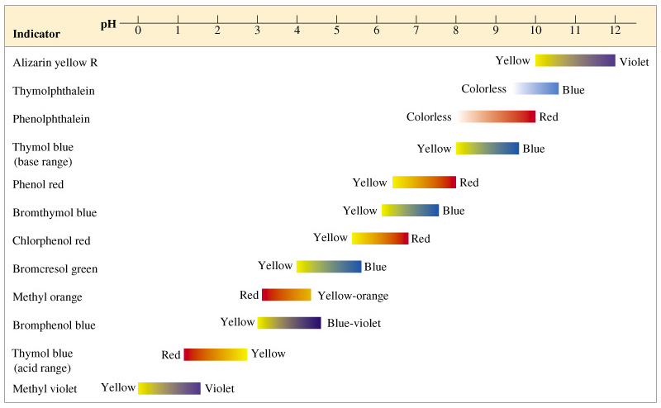

Station #11: Titrations

- A 15.5 mL sample of 0.215M KOH solution required 21.2 mL of aqueous acetic acid (HC₂H₃O₂) in a titration experiment. What is the molarity of the acetic acid?

2. By titration, 17.60 mL of HNO₃ neutralized 29.30 mL of a 0.016500 M LiOH solution. What was the molarity of the acid?

3. Sketch a diagram of the following moments during a titration of hydrochloric acid with sodium hydroxide. Your diagram must contain a minimum of 3 complete molecules (or 3 ion pairs):
(a) The moment right before the titration endpoint.
(b) The moment just after you overshot the endpoint.
(c) The moment you’ve just neutralized all of the acid with the base at the endpoint.

Station #12: Nomenclature Again!
A. Copy the following compounds on the table and give the chemical name for the following:

1. SrSO₄
2. IrCl₆
3. N₂O₅
4. H₂SO₄ (aq)
5. Pt(NO₂)₂
6. Cd₃(PO₄)₂
7. (NH₄)₃P
8. HgO

B. Copy the following compounds on the table and write the chemical formula for the following:

1. Beryllium Oxide
2. Aluminum Chloride
3. Calcium Carbonate
4. Gold (III) Nitrate
5. Lead (II) Phosphide
6. Silicon Dioxide
7. Magnesium Phosphate
8. Scandium (IV) Sulfate
9. Cesium Nitride
10. Disulfur Octaoxide

