**Chemistry I**

**Final Exam Study Guide**

**Atom Basics**

1. How do you find the number of neutrons in an atom?
2. How many neutrons are in $\begin{matrix}91 \\ 40\end{matrix}$ Zr?
3. Create 2 isotopes of carbon and represent them in both isotope formats.
4. What is the mass of protons? Neutrons? Electrons?

**Nuclear**

1. What are the 3 types of radiation?
2. Which type of radiation has the highest penetrating power?
3. After 30 days, 5.0 grams of a radioactive isotope remains from an original 40.-gram sample. What is the half-life of this element?
4. Given the following nuclear reaction,  Identify *X*, include the mass and atomic numbers.
5. What are the symbols used for each type of radioactive decay?
6. Define nuclear fission and nuclear fusion.

**Electrons**

1. According to Niels Bohr's atomic model, what occurs when an atom *absorbs* radiated energy?
2. A hydrogen atom emits a photon of energy. Explain how this can happen.
3. According to Bohr's model, what can be said of the amount of energy that an electron absorbs when it is excited compared to the amount of energy that it releases when it returns to ground state?
4. Using the Bohr Diagram on your reference sheet, what color is emitted by an electron that drops from n= 4 to n= 2?
5. Using the Bohr Diagram on your reference sheet, what energy level transition is indicated when the light emitted by a hydrogen atom has a wavelength of 103 nm?
6. Electron *X* can change to a higher energy level or a lower energy level. Explain what has to happen in either scenario.
7. When the electron of a hydrogen atom moves into a higher energy orbit, what is the state of the atom?
8. What happens when a hydrogen atom changes from the excited state to the ground state?
9. When an electron moves from n= 3 to n=2, what wavelength of energy is emitted?
10. An electron moves from n= 4 to n= 1. What region of the EM spectrum is the wavelength located?

**Electron Configuration**

1. Write the electron configuration of nickel.
2. Write the noble gas configuration for Cu.
3. Write the orbital notation for N.

_____ _____ _____ _____ _____ _____ _____ _____ _____ _____ _____ _____ _____ _____ _____

1s 2s 2p 3s 3p 4s 3d

**Periodic Trends**

1. What is the definition of electronegativity?
2. What is the trend in electronegativity across a period? Down a group? (include nuclear charge and electron shielding in your description of trends)
3. What is the definition of ionization energy?
4. What is the trend in ionization energy across a period? Down a group? (include nuclear charge and electron shielding in your description of trends)
5. What is the definition of atomic radius?
6. What is the trend in atomic radius across a period? Down a group? (include nuclear charge and electron shielding in your description of trends)

**Periodic Table**

1. List the main families and their respective oxidation numbers.
2. List at least 2 similarities for each family.
3. What elements are metalloids? What are metalloids?
4. Looking at the periodic table, list 4 atomic numbers that represent elements with similar chemical properties. Why did you choose those numbers?

**Bonding**

1. Describe metallic bonding (what is unique about the electrons). What are the properties of metallic bonds?
2. Describe ionic bonding (what is unique about the electrons). What are the properties of covalent bonds?
3. Describe covalent bonding (what is unique about the electrons). What are the properties of ionic bonds?
4. What are the 5 major shapes of covalent molecules? How can you determine the shape?
5. What is the difference between polar and nonpolar molecules?

**Naming**

1. What is the name of the compound N2O3?
2. What is the chemical formula for the compound tetraphosphorus decasulfide?

|  |  |  |  |
| --- | --- | --- | --- |
| **1** | **mono** | **6** | **hexa** |
| **2** | **di** | **7** | **hepta** |
| **3** | **tri** | **8** | **octa** |
| **4** | **tetra** | **9** | **nona** |
| **5** | **penta** | **10** | **deca** |

1. What is the name of the compound with the formula FeCl3?
2. What is the name for SnO2?
3. What is the name of the compound with (NH4)2CO3?
4. Which is the formula for Calcium hydroxide?
5. What is the chemical formula for sulfuric acid?
6. What is the formula for lead (II) chromate?
7. What is the chemical formula for hydrochloric acid?

**Chemical Reactions**

1. Predict the products for: Copper and HCl, Magnesium and HCl and Iron and HCl. What will you observe as a result of these reactions?
2. Predict the products resulting from the decomposition of sodium chlorate.
3. Write a balanced equation when Lithium and oxygen react in a synthesis equation.
4. Write the reaction that occurs between Fe(NO3)3 and KOH.
   1. Balance the reaction.
   2. Write the complete ionic equation.
   3. Write the net ionic equation.

**Potential Energy Diagrams**

1. Draw an endothermic and exothermic potential energy diagram. Label reactants, products, change in enthalpy, energy of reactants, energy of products, activation energy and activated complex. Include a catalyst. How does a catalyst affect the reaction?
2. Given the energy diagram below, what information can be obtained from it?

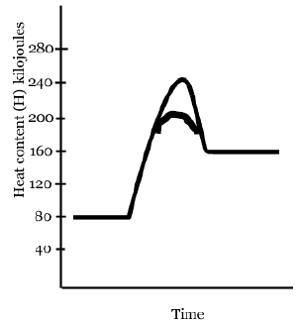

1. Pair endothermic and exothermic reactions with the correct change in enthalpy : positive / negative.

**Stoichiometry**

1. Fluorine gas can react with ammonia gas to produce dinitrogen tetrafluoride gas and hydrogen fluoride gas: 5 F2 (*g*) + 2 NH3 (*g*)    N2F4 (*g*) + 6 HF (*g*). What mass of hydrogen fluoride gas is produced from 335 g of ammonia gas assuming that there is an ample amount of fluorine gas present for the reaction to be completed?
2. How many moles of nitrogen would be needed to completely react with 5 moles of hydrogen according to the balanced equation given? N2 + 3H2 2NH3
3. If 22 grams of NH3 are used in this reaction, how many Liters of nitrogen (N2) will be produced? (Use the equation from the previous question)
4. What is the percent by mass of oxygen in Al2O3 ?
5. The molar mass of a compound is 92.0 g/mol. It contains 14.7 g N and 33.6 g O. What is its molecular formula?
6. What is the empirical formula of a compound that contains 75% C and 25% H by mass?
7. If a sample of magnesium has a mass of 45.0 g, how many atoms of magnesium does the sample contain?
8. What is the percent by mass of oxygen in Beryllium oxide, BeO?
9. What would be the empirical formula of a compound that is 25.5% carbon, 6.40% hydrogen, and 68.1% oxygen?

**Solutions, Acids and Bases**

1. When 0.50 liter of a 7 M solution is diluted to 1.0 liters, what will the new Molarity of solution be?
2. What is the total number of grams of KOH needed to make 1.0 liter of a 0.25 M solution?
3. The pH of an unknown solution is 8. Is it an acid or base? What is its pOH?
4. What primarily determines the pH of a solution?
5. What is the pH of a solution that has an OH- ion concentration of 1× 10-3 mole per liter? Is it an acid or base?
6. What is the H+ of an HCl solution if the pH is measured to be 4?
7. What is a characteristic of a strong acid?
8. What is the difference between strong and weak acids?
9. What is the Bronsted-Lowry definition of an acid? Base? How is water classified?

Use the following Solubility Graph to answer questions

1. Which compound is *least* soluble in water at 40.°C? *most* soluble?
2. Under which conditions are gases most soluble in water?
3. How do you read a solubility graph?
4. According toReference Table *G*, a temperature change from 60°C to 90°C has the *least* effect on the solubility of
5. How do you know if a solution is saturated, unsaturated, or supersaturated?
6. What are colligative properties? What properties are changed, and how?
7. Acid-base reactions form what two products? What is the name of this type of reaction?



**Equilibrium**

Consider the following system in equilibrium when completing chart below:

3H2(g)+ N2(g)2NH3(g) + 22,000 J

1. Write the equilibrium expression for the system.
2. 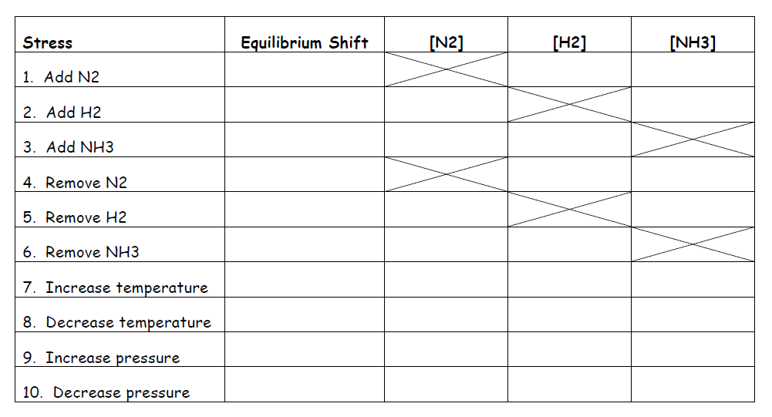Complete the table:

**Phase Changes**

1. Draw a phase change diagram and label the triple point and critical point. Label solid, liquid, and gas.
2. Which phase changes are exothermic?
3. Which phase changes are endothermic?

**Energy**

1. How much heat energy must be absorbed to completely vaporize 50.0 grams of H2O(l) at 100°C?
2. Draw a heating and cooling graph. Label the states of matter at each section. Label the correct heat energy equation for each section of the graph. Label the phase change sections.

**Gases**

1. What is the total pressure for a mixture of gases that contains four gases with partial pressures of 15.00 kPa, 4.56 kPa, 8.02 kPa, and 3.20 kPa.
2. The following data were recorded during experiments with a fixed amount of neon gas. Assuming that the gas was ideal, how many moles were there of the gas?

|  |  |  |
| --- | --- | --- |
| Pressure (atm) | Volume (L) | Temperature (K) |
| 5.6 | 35.0 | 320 |

1. A gas occupies a volume of 484 mL at 293 K and 99.0 kPa. What is the final kelvin temperature when the volume of the gas is changed to 1480 mL and the pressure is changed to 36.7 kPa?
2. Why does the volume of a gas decrease when the temperature decreases?
3. A balloon contains 5.5 L of air at 313 K and 101.3 kPa. After an hour, the air inside the balloon cools to 277 K. What is the final volume of the air in the balloon?