Chemistry I-Standard
Half-Life Problem Set

Complete the following half-life problems. Clearly indicate your answer.

- An isotope of cesium-137 has a half-life of 30 years. If 1.0 mg of cesium-137 disintegrates over a period of 90 years, how many mg of cesium-137 would remain?

- A 2.5 gram sample of an isotope of strontium-90 was formed in a 1960 explosion of an atomic bomb. The half-life of strontium-90 is 28 years. In what year will only 0.625 grams of this strontium-90 remain?

- Actinium-226 has a half-life of 29 hours. If 100mg of actinium-226 disintegrates over a period of 58 hours, how many milligrams (mg) of actinium-226 will remain?

- Sodium-25 was to be used in an experiment, but it took 3.0 minutes to get from the reactor to the laboratory. If 5.0 mg of sodium-25 was removed from the reactor, how many mg of sodium-25 were placed in the reaction vessel 3.0 minutes later if the half-life is 60 seconds?

- If the passing of 4 half-lives leaves 0.425 grams of astatine-210, how many grams of the sample was present initially?

- Selenium-83 has a half-life of 25.0 minutes. How many minutes would it take for a 10.0 mg sample to decay and have only 1.25 mg of it remain?

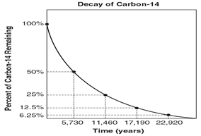
Use the graph to the right to answer questions 7-9.

- What is the half-life of carbon-14? _____________

- What percentage of carbon-14 remains after 17,190 years?

- Predict what percentage of the original carbon-14 sample will remain after 28,650 years. ____________

- True or false: Elements with stable nuclei are radioactive.

