Chemistry I-Standard
Introductory Concepts Notes

The study of Chemistry heavily requires the use of basic math and algebra concepts on an almost daily basis. The beauty of Chemistry is that it is a math, history, English, and science class rolled all into one. We will be using skills from all of these classes in order to make sense of the Chemistry we are studying. The purpose of this introductory unit is just that: to introduce (or rather re-familiarize) you with the basic math concepts necessary in this course.

I. │ Scientific Notation: Expressing large and small numbers

- In Science, we must work with incredibly large and small quantities. Some of these examples include:
- the speed of light which is 300000000 m/s
- the equilibrium constant for the ionization of water which is 0.00000000000001

- You can see the problem with these values is the massive amounts of zeros they contain. In our study of Chemistry, we simply do not have the time to write these numbers out in the long form presented above.

- Scientific Notation is an application used by scientists and mathematicians to express large and small quantities in a more manageable way. It uses a superscript notation paired with powers of ten.

- For large numbers the power of ten is a positive number. For small numbers the power is a negative number. The superscript number (power) is found by how many times the decimal is moved so that it is in between the first two digits.

Sample Problem: Express these values in scientific notation:

a. 45600000 = ________________________

b. 0.00000025678 = ___________________

- For additional practice, let’s convert the first two values we encountered into scientific notation. Write these numbers in the margin next to these numbers.

II. │ Basic Algebra Skills

- The major algebra skill we will use in this course is the identification, rearranging, and solving of algebraic expressions. While there are a large variety of equations used in this course, what is most important is the skill of identifying the correct equation and being able to digest the equation so that you may manipulate to produce a desired result.

- In Chemistry, we do not memorize equations! We instead are given the equations and it is our job to figure out when to use these equations. Let’s look at some simple algebraic expressions:

Sample Problem(s): Solve the following algebraic expressions for the indicated variable:
a) 4x + 3 = 10 for “x”

b) 10x – 7 = 13x + 11 + 15 for “x”

-2-
(continued from previous page)

Sample Problem: Solve the following algebraic expressions for the indicated variable (use your yellow reference table):
c) Formula number 5, for “M₂"

d) Formula number 6, for “T”

- Of course, we practice solving algebraic expressions so that we can eventually evaluate these expressions with an actual number. We will follow these steps every time we solve an algebraic expression in this class:
- Identify the equation and variable to solve.
- Write the expression in terms of the indicated variable.
- Plug in values for known quantities.

Sample Problem: Solve each equation for the unknown variable and then evaluate each expression using the values given:

a) _______ formula #3 for T₁ where (V₁ = 10 L, P₁ = 2 atm, T₂ = 100K, V₂ = 5 L, P₂ = 4atm)

b) _______ formula #6 for P where (V = 10 L, n = 2 mol, R = 0.0821 L*atm/(mole*K),
T= 100 K)

III. │ English vs. Metric Units and the International System of Units

- In the United States, we use the English system of measurement. This means that we measure distances in miles, yards, and inches whereas most of the remainder of the world uses meters and its variants (millimeters, centimeters, etc.).

-3-

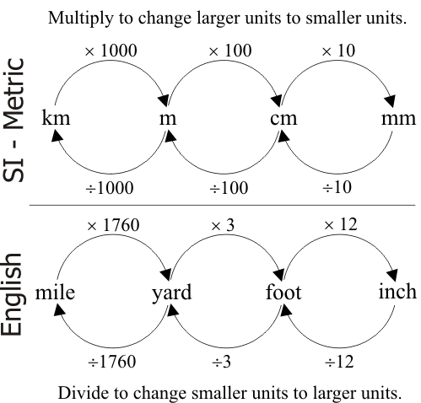
- The problem with the metric system is that it is quite cumbersome to convert between these units. It comes down to memorizing that there are 12 inches in 1 foot and 3 feet in a yard. There is too much to memorize.

- In the metric system, however, all of the subdivisions are separated by a factor of 10. Now memorization is unnecessary!

- Notice the comparison of the English and metric systems to the right.

The following is a list of SI units and what it measures:
Mass | kilogram (kg)
Time | second (s or sec)
Length | meter (m)
Quantity (Amount of substance) | mole (mol)
Luminous Intensity | candela (cd)
Electric current | ampere (A or amp)
Temperature | Kelvin (K)

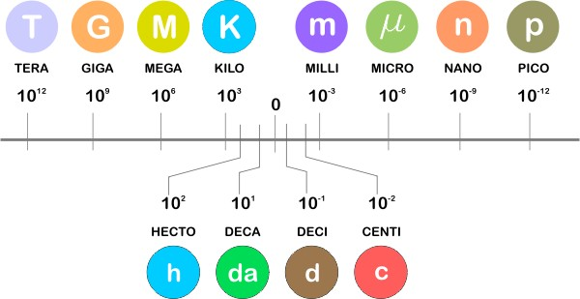
- As mentioned before, the subdivisions of the metric system are separated by a factor of 10. Each of these subdivisions has its own prefix (e.g. centimeter vs. millimeter where meter is what we call the base). The prefixes of the metric system adopt the following scale: (change deca to deka, dk)
- We will not be using the entire scale. The only prefixes we will be using in this course will be from kilo to centi. We will use the following mnemonic device to remember the order:

kilo, hecta, deca, base, deci, centi, milli

“king henry died by drinking chocolate milk”

Sample Problem: Determine the following equivalents using the metric system prefixes:

a) 1000 mg = _______ g b) 1 L = _______ mL

c) 160 cm = _______ mm d) 14 km = _______ m

e) 109 g = _______ dg f) 250 hm = _______ cm
-4-
IV. │ Dimensional Analysis with Factor-Label Method

- Now that we know about different units and their prefixes, it is only natural that we discuss how to interconvert between these units. This is an incredibly important skill. Especially because we use conversions all the time in our daily lives.
- The types of conversions we will see in this class: English-to-English, Metric-to-Metric, and Engligh-to-Metric (and vice versa).
- Dimensional Analysis: a problem solving method that uses the fact that any number or expression can be multiplied by “one” without changing its value.
- Do not be intimidated by the words Dimensional Analysis. It’s just a fancy phrase for saying we are going to use a method (or tool) to convert one number into another.
- Discuss Factor-Label Method: given, need, and know numbers │ drawing chart

Sample Problem #1: The average weight of an African Forest Elephant is 6250 pounds (lbs). How many tons is this?

Sample Problem #2: A cooking pot contains 345 fluid ounces (fl. oz.) of water. How many cups is this?

Sample Problem #3: A high school swimmer competes in the 100-meter backstroke event. How many centimeters does this athlete swim?

Sample Problem #4: The same swimmer now competes in a different event, the 350-meter front stroke. How many inches does this athlete swim? (Hint: multi-step problem)

Sample Problem #5: A length of 2.56 dekameters (dkm) is equivalent to how many feet?

Challenge Problem: The running back for the best football team in the world recognizes that in order to get a first down that he must make it 2 yards. He is able to run 2356-mm before being tackled. Did the team get the first down? Explain your answer.

Final Notes: (1) important conversion factor: 1cm³ = 1 mL, (2) Using references, (3) Intro Concepts Assessment
-5-

Notes on the Basics of Chemistry

One of the most widely accepted definitions for chemistry is the following:

“Chemistry is the study of matter and the changes it undergoes.”

Implicit within this definition is the idea of change. How does something look now and how did it look before a certain process occurred? As chemists, we are obsessed with categorizing and describing these changes. While there are many different types of processes we will discuss in this class, it will be most beneficial for you, as a first time Chemistry student, to endeavor to make connections between not only what you are observing in this course, but what you have seen in previous courses (History, Language, and Math, too) and in your daily life.

The Periodic Table of the Elements

The most important tool we will use in this course is the Periodic Table of the Elements. This work of art is not just a pretty picture we hang on a wall but is an instrument we will use to gather a great deal of information. Below is a partial periodic table which excludes 35 of the most common elements featured in this course. You must memorize the name, symbol, and location of these most common elements.
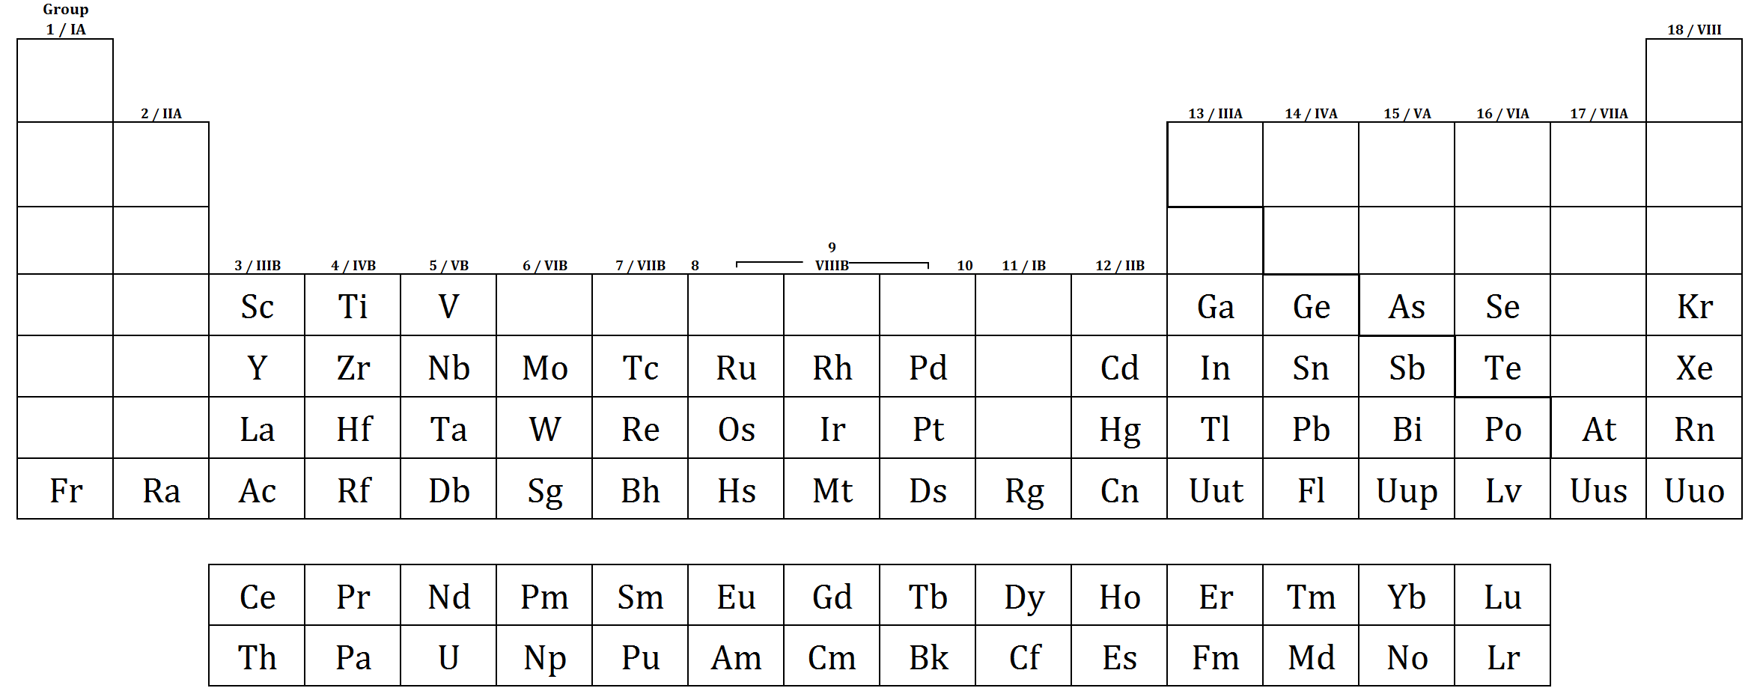

Classification of Matter

There are two principles ways in which matter can be classified: according to its physical state (as a gas, liquid, or solid) and according to its chemical composition (element, compound, or mixture). We are most concerned in this introductory unit with the latter. We will spend time describing the physical states later in the course. It is increasingly common for students to confuse the difference between an element, atom, and compound.

Definitions:
- Element: _________________________________________________________________________
- Atom: ___________________________________________________________________________
- Compound: _______________________________________________________________________
_________________________________________________________________________________

-6-
Classification of Matter

Matter

Pure Substance Mixture
(Homogeneous) (Homogeneous or Heterogeneous)

true True Element Compound Solution Colloid Suspension
Element Compound solutions colloids suspensions
[May be single
atoms or molecules]

Metals Nonmetals Noble Gas Inorganic Organic Organo-Metallic
Metalloid

Electrolytes Non-electrolytes

Acid Base Salt Amphoteric
[covalent molecules or ionic compounds]
...............................................................................

Phase: region with a similar set of properties

Interface: site where two phases meet

Solutions: make sure it is known that mixtures can occur for all states
Solvent / Solute / Solution
Solute - substance that is dissolved (usually the smaller amount)
Solvent - substance that does the dissolving

Colloids: dispersed & dispersing mediums - similar to solute & solvent in solutions
Tyndall effect: scattering of light in colloids by the dispersed medium
-7-
Polyatomic Ions

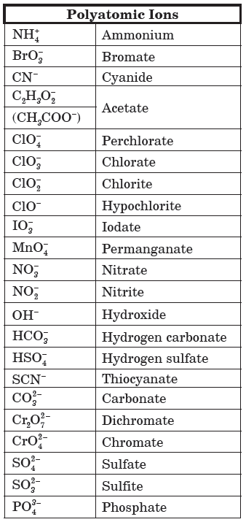
Polyatomic ions (PAIs) is a charged chemical species composed of two or more atoms bonded together which are considered to be acting as a single unit (just like elements).

These polyatomic ions are listed to the right. Consider phosphate:

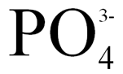

Discuss the difference in numbers. –ate and –ite endings. Show structure of ion.

Classification of Matter In-Class Examples:
Determine whether the following substances is an element (E), compound (C), or a mixture (M).

1. _______ | Table Salt (NaCl) | 9. _______ | Sweet Tea
2. _______ | Apple | 10. _______ | Silver
3. _______ | Plutonium | 11. _______ | Pure air
4. _______ | Water | 12. _______ | Carbon Dioxide
5. _______ | Calcium | 13. _______ | Kool-Aid
6. _______ | Iron(II) nitrate | 14. _______ | Mud
7. _______ | Gasoline | 15. _______ | Bronze
8. _______ | Calcium Bromide | 16. _______ | Chicken soup

Notes on Data Analysis

At the foundation of this course is discerning information from graphs, charts, and tables. This is science, of course, and we must use these aforementioned skills if we are to make informed decisions about the Chemistry we are to study.

-8-
- Graphing Basics:

A graph must contain the following: (1) _____________________ (2) ________________________

(3) __________________________________ and (4) _____________________________________.

In-Class Example:
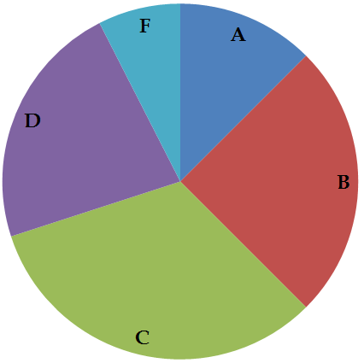
The grades of a class were graphed as a pie chart. Based on this chart:

(a) The largest percentage of students received what grade? ________
(b) The smallest percentage of students received what grade? _______
(c) Estimate what percentage of the class received a B. ___________
(d) Based on the graph, do you think this class is hard?
Explain below. (i.e. Why or why not?)

Graphing activity:
As a class determine: (1) What data will we collect? (2) How will we collect it? (3) What is the best graph to use to display the data? (4) The appropriate scale to use on the graph? (5) Does your graph incorporate the necessary criteria?

