Chemistry I-Standard
Orbital Diagrams Problem Set

1. What is the difference between the previous models of the atom and the modern quantum mechanical model?

2. The further the electron is from the nucleus, the _______________ energy the electron has.

3. A(n) ________________________ is often thought of as a region of space in which there is a high probability of finding an electron.

4. What is the term used to label the energy levels of electrons? _________________________________

5. How are s orbitals different from p orbitals? ______________________________________________

6. How many electrons can each of the following orbitals hold?
a. 2s = ________ d. 6d = ________

b. 3p = ________ e. 4p = ________

c. 5f = _________ f. 3d = ________

7. How many “p” orbitals can there be in any energy level? ____________________________

8. What is the maximum number of electrons in the 3rd principle energy level? __________________

9. How many orbitals are in each of the following sublevels??

a. 4p sublevel ____________ c. 4f sublevel ____________

b. 3d sublevel ____________ d. 2s sublevel ____________

10. Which element has the following orbital diagram?
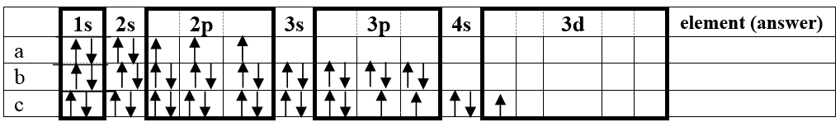

11. Using arrows, show how the following orbitals will fill with electrons.
 | Electron Configuration | 1s | 2s |  | 2p |  | 3s |  | 3p |  | 4s |  |  | 3d
Mg | 1s²2s²2p⁶3s²
Cl | 1s²2s²2p⁶3s²3p⁵
Si | 1s²2s²2p⁶3s²3p²
Ti | 1s²2s²2p⁶3s²3p⁶4s²3d²

