Chemistry I-Standard
Molecular Polarity & Intermolecular Forces Practice

1. Briefly describe the difference between molecular and bond polarity. How are they alike? How are they different? Be sure to address all prompts.

2. For the following set of molecules determine if they are polar (P) or nonpolar (NP) based on a correctly drawn Lewis structure:

a. ____ | 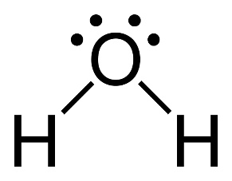 | b. ____ | 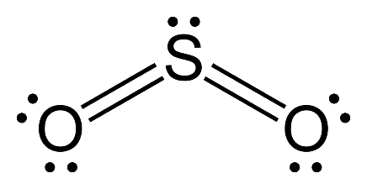 | c. ____ | 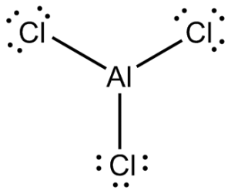
d. ____ | PH₃ | e. ____ | SiO₂ | f. ____ | CF₄

3. Determine the intermolecular forces for these substances using the following key:

A) London (dispersion); B)dipole-dipole; C) H-interactions (bonding); D) macromolecule

a. _______ PCl₃ f. _______ DNA

b. _______ HI g. _______ ammonia (NH₃) gas

c. _______ SO₃

d. _______ liquid bromine

e. _______ oxygen dibromide gas

f. _______ helicase (a protein)

