Chemistry I-Standard
Quantum Theory & Periodic Properties Lecture Notes

In our study of matter so far, we’ve discussed primarily the number of protons, neutrons, and electrons a particular piece of matter possesses. This led to a discussion about the stability (or lack of stability) of certain substances: Why is the calcium in your bones one of the most stable substances known to man, whereas the uranium being harnessed and split in nuclear reactions all over the world is incredibly unstable? What we have neglected in the discussion is the all-important electron. Where are electrons in the atom? Is there an order, or structure, to where they exist in the atom? This unit seeks to answer these questions. We will spend time discussing the location of electrons in an atom and, ultimately, how the location of the electrons demonstrates the overall chemical characteristics we have come to discover about an individual species.

I. Development of Modern Quantum Theory

- Quantum is defined as: ________________________________________________________________ ___________________________________________________________________________________.
- Quantum Theory is defined as: __________________________________________________________ ___________________________________________________________________________________.
- The scientists who developed this theory were concerned with describing the microscopic world (subatomic particles) the way the earlier scientists had described the macroscopic world. Consider any random object located around the room. What physical properties can you describe about this object (write in the space below):

- These scientists discovered that similar treatments they attempted to apply to macroscopic objects (the one we just described) did not apply to fundamental particles like electrons.

- Why do we study quantum theory?
- When we study the mechanics of electrons (quantum theory) we can understand, and predict, how certain chemicals will behave.
II. The Electromagnetic Spectrum: Qualities and Characteristics of Quanta

- How do we classify different types of quanta in terms of their composition?
- Let’s consider our random object again! Would you say that this object is made of particles or waves? How do you know? Write your answer in the space below:

- What about the light coming from the lightbulbs in the room? Would you consider these particles or waves? How do you know? Write your answer in the space below:

- Wave-particle duality: It turns out that all matter consists of both particles and waves. This is how we can tell the mass of a tennis ball but also that it has its characteristic color (our eyes can detect wavelengths).
-2-

- The electromagnetic spectrum shows different types of radiation based on wavelength. 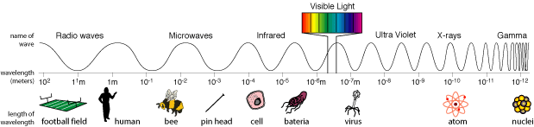

- Ground State: Electrons are in the lowest possible energy level.
- Excited State: Any state higher in energy than the ground state. Energy is added, causing electrons to “jump” energy levels (this process is called absorption).
- As electrons fall back to their original energy level, light is given off (this process is called emission).
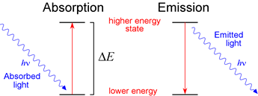
Light equations:
- Wavelength (λ): Length from crest to crest (meters is the base unit)
- Frequency (ν): number of waves that pass a point in a second (measured inverse sec or hertz- Hz)
- Energy (E, or ΔE): The ability for something to do work (measured in Joules “jool”, or J).
- Speed of light (c) = 3.00 x 10⁸ m/s. This value is a constant, meaning it will stay the same.
- Planck’s constant (h) = 6.626x10⁻³⁴ J∙s

Sample Problem #1: You are given the wavelength of a particle as 3.5 x 10⁻⁵m. What is the frequency of the particle?

Sample Problem #2: Given the particle in the previous problem, how much energy does this particle possess?

Sample Problem #3: Based on these calculations, how would you describe the relationship between the properties of a particle – frequency, wavelength, and energy?

- So far, we can tell a great deal about electrons. We know the mass of an electron, we can tell how much energy the electron has, assuming we know something about its wavelength, or frequency.

- The only thing we do not know is where (specifically) the electron can be found in the atom. How have we described the location of the electrons in an atom before? Write it in the space below:

-3-

III. Bohr Diagrams: Interpretations of Electronic Structure

- In the early 1900s, the question we posed on the previous page was the main question on the minds of scientists. We knew so much about what made the elements physically different (the number of protons, neutrons and electrons). We also knew how the protons and neutrons were organized in the atom. But we knew nothing about how the electrons were organized.

- While there were many scientists who attempted to answer this question, one scientist had the greatest impact on how we organize electrons.

- Niels Bohr postulated that electrons orbited the nucleus of the atom just like the planets orbit the sun.
- The Bohr diagram shows the location and number of the protons and neutrons in the nucleus, with the electrons in the electronic cloud.
- The number of rings around the nucleus represents the row on the periodic table the atom sits in.
- Certain rings can only hold a certain number of electrons: 1st ring – 2 electrons, 2nd ring – 8 electrons, 3rd ring – 8 electrons.
- His model only worked for hydrogen. It did not work for all of the other elements.
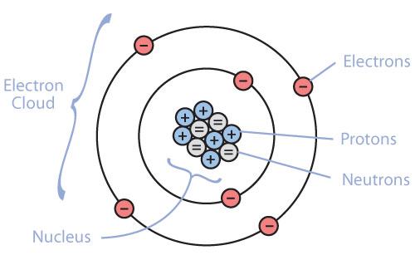
- What element is represented by the diagram above? How do you know? Answer in the space below:
Note: not all neutrons are depicted in the diagram.

- It should be noted that while Bohr’s model is a good tool for visualizing the electronic structure of the cloud, it is not consistent with actual experimentation. It only provides a “snapshot” of the atom.

Sample Problem #1: Using the Bohr Model for the Hydrogen Atom, (a) determine the wavelength (with the appropriate units) of an electron as it falls from the third energy level (n=3) to the first energy level (n=1) and (b) determine the type of electromagnetic radiation it is.

Sample Problem #2: Draw Bohr Diagrams for the following elements: beryllium (Be), fluorine (F) and phosphorous (P). Represent the protons and neutrons with the elemental symbol.

-4-

IV. Structure of the Electronic Cloud

- Now that we have a general look of the electronic structure of the atom, we need to make more specific claims of where electrons are located in the atom.

- Remember that Bohr’s model did not work out for every element on the periodic table. Another scientist by the name of Erwin Schrödinger came up with a model that is consistent with experimental data and calculations.

- The quantum mechanical model of the atom is how we describe the structure of the electronic cloud. This model of the atom is a statistical model of the atom. This means the model is a reflection of where we think the electron is.
- There is no way of knowing with 100% accuracy the location of the electron, if we know its speed. The opposite is true too. If we know the location, then we cannot know its speed. This idea is called the Heisenberg Uncertainty Principle.
- It is another way that quantum mechanics is different than classical mechanics.

- The periodic table can be organized into what are known as blocks. On the periodic table below, label the following block: s, p, d, & f.
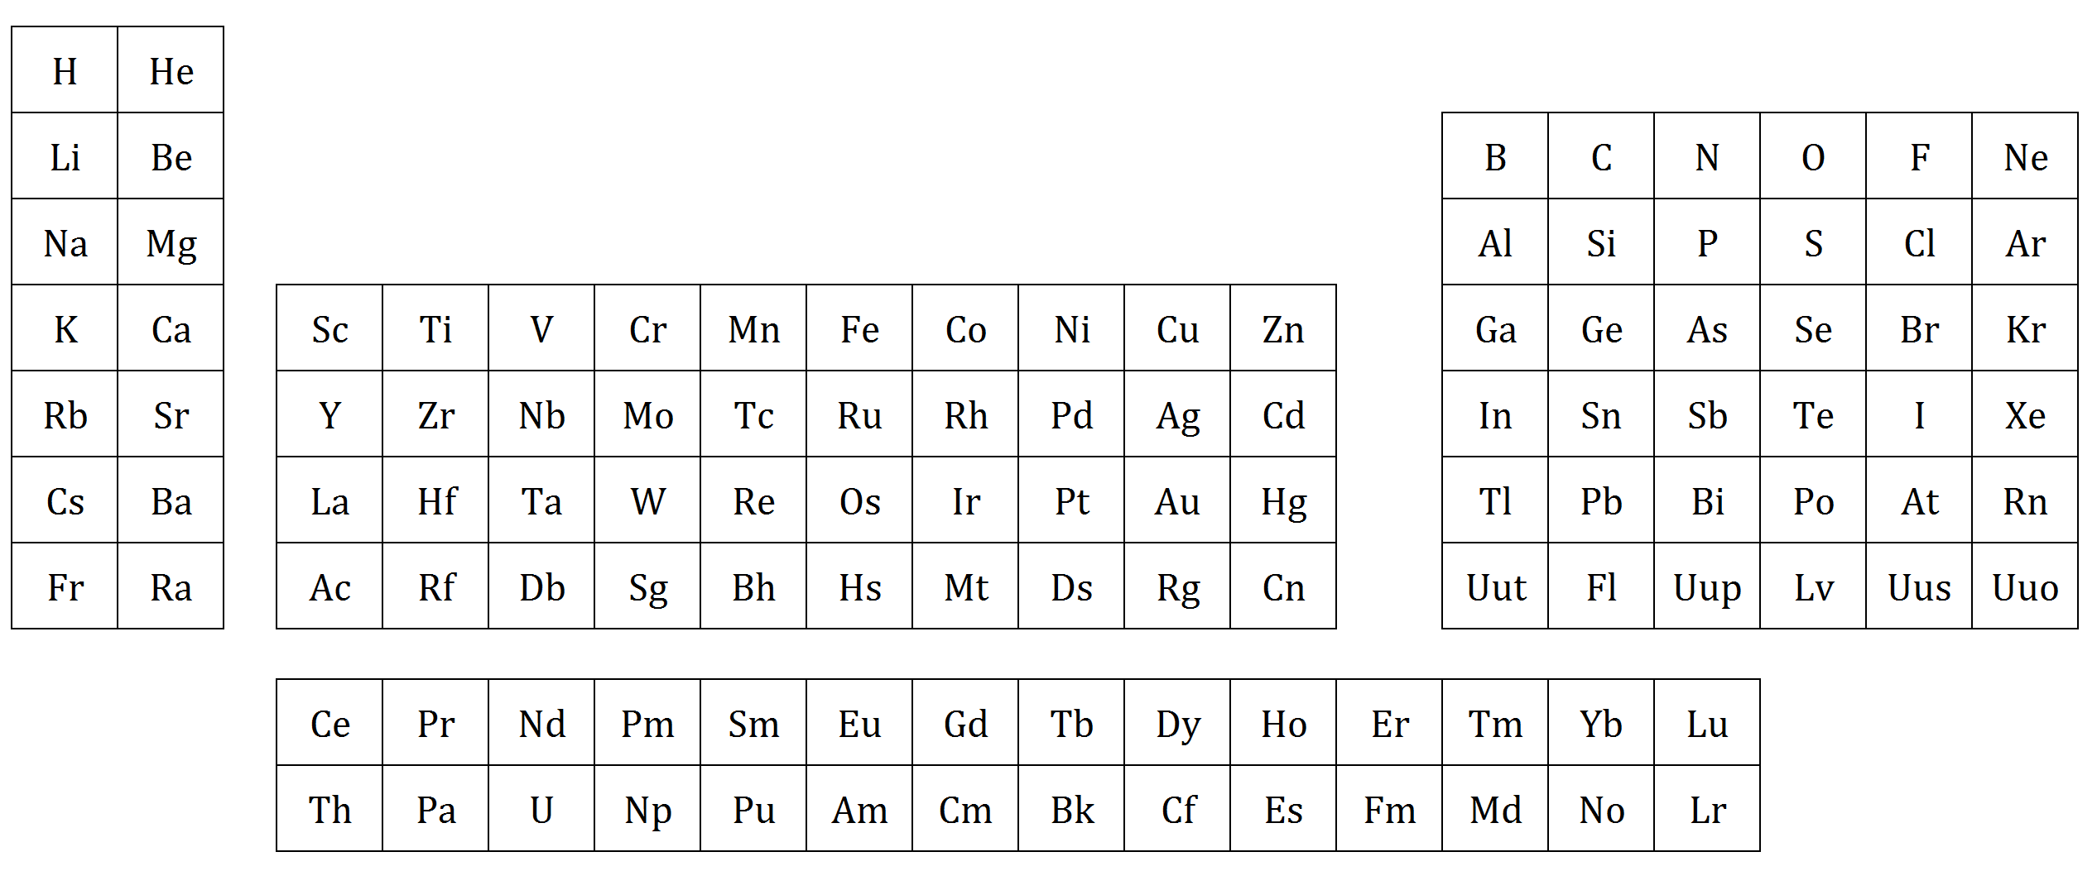
- Essential question: What do you notice is different about this periodic table versus the periodic table you’ve seen before? Answer in the space below:

- Each of the blocks can hold a certain number of electrons.
- s = ____ p = ____ d = ____ f = ____
What do you notice about the number of electrons and the number of elements in the block?

-5-

- There are 3 main levels of organization which describe the structure of the electron cloud:

- Energy level: _____________________________________________________________________ ________________________________________________________________________________.
- Energy sublevel: ___________________________________________________________________ ________________________________________________________________________________.
- orbital: __________________________________________________________________________ ________________________________________________________________________________.
- Discuss the number of electrons which can fit into each orbital.

- The difference between an energy level, a sublevel, and an orbital can be difficult to discern. Let’s consider a real-world model that would make more sense to us. Consider an average suburban house:

In this example the:

- Floors of the house represent:

- Rooms of the house represent:

- The chairs of the house represent:

- Drawing orbital diagrams: An orbital diagram is much like the schematic of the house above – it shows the precise location of all objects. But also notice that it shows all objects in relation to the other objects as well.

- Rules to Filling Orbital Diagrams:
- Aufbau Principle: electrons occupy the lowest energy level possible (as close to the nucleus )
- Hund's Rule: Electrons tend to stay unpaired as long as possible
- Pauli Exclusion Principle: No two electrons can occupy the same orbital with the same direction (spin).
-6-

Sample Problem #1: Draw an orbital diagram for a neutral atom of beryllium (Be, Z=4)

Sample Problem #2: Draw an orbital diagram for a neutral atom of carbon (C, Z=6)

Sample Problem #3: Draw an orbital diagram for a neutral atom of cobalt (Co, Z=27)

V. Electron Configurations

- Electron configurations are another way to depict orbital diagrams. They present the number of electrons in the same order but with a different notation.
- Let’s examine a couple of orbital diagrams to note their similarities and differences:

Element | Orbital Diagram | Symbol
# 1 |  | ________
# 2 |  | ________

Essential Questions:
- What neutral elements are represented by the orbital diagrams above? Write them in the spaces provided above.
- What are some differences between the orbital diagrams? List them below:

- What are some similarities between the orbital diagrams? List them below and circle the most important:

- On your yellow periodic table, write the energy level where each of the blocks of the periodic table begin: “s” block starts at 1st energy level, “p” block starts at 2nd energy level, etc.
-7-

- Similarities in Electron Configurations:
- All of the electron configurations start the same way because electrons fill energy levels, sublevels and orbitals in the exact same way. It’s how they end that is different!
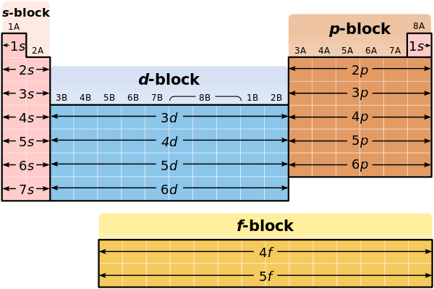

- Steps to writing electron configurations:
- Locate the element on the periodic table.
- Identify the sublevel for the element.
- Read the periodic table like a book to write the sublevels and electron number in the correct order.
- Check: Ensure the number of electrons are correct.

Sample Problem #1: Write an electron configuration for a neutral atom of magnesium (Mg, Z=12)

Sample Problem #2: Write and electron configuration for carbon (C, Z=6). What do you notice about the orbital notation diagram on the previous page?

Sample Problem #3: Write an electron configuration for a neutral atom of bromine (Br, Z=35)?

- Some electron configurations can get incredibly long! There is a short-hand notation called the noble gas configuration. Look at the noble gas configuration for bromine below:

Can you write both the electron and noble gas configurations for a neutral atom of mercury (Hg, Z=80)?

-8-

VI. Periodic Properties

The periodic properties (or periodic trends) are a host of relationships embedded within the periodic table. We start off our discussion with a brief history of the development of the periodic table with emphasis on how the periodic table obtained its unique structure. Then, we delve into important terms which frame the discussion of the relevant periodic trends, and finally, we will illustrate how the tenants of quantum theory is a direct relationships to the chemical properties of the elements and the repeated trends observed on the periodic table.

Origin of the Periodic Table
- Mendeleev proposed the first arrangement of elements known as the Periodic Table. He arranged the elements by atomic mass.
- Found that as he arranged elements, similar properties kept repeating themselves.
- There were “gaps” in his table, which led scientists to look for & discover new elements.
- Moseley devised the current periodic table based on atomic number.
- Scientists found that elements in the same group have similar chemical properties (i.e. they react the same way). They concluded that this was because they have the same number of valence electrons. Atoms ultimately want to have an “octet” (8 electrons in the outer energy level) and will give/take or share electrons to achieve this goal.
- Important Terms:
- Periodic Law: “Physical & chemical properties of elements are periodic functions of their atomic numbers” (i.e properties of elements are related to the number of protons an element has).
- Groups / Families : Vertical columns on the periodic table (1-18)
- Periods / Rows: Horizontal rows on the periodic table (1-7)

Effective Nuclear Charge

Read the following paragraphs and highlight any words you are unfamiliar with.
An atom of Hydrogen consists of a single proton surrounded by an electron that resides in a spherical 1s orbital. Recall that orbitals represent probability distributions meaning that there is a high probability of finding this electron somewhere within this spherical region. This electron, being a negatively charged particle, is attracted to the positively charged proton.
Now consider an atom of helium containing two protons (there are neutrons in the nucleus, too, but they are not pertinent to this topic) surrounded by two electrons both occupying the 1s orbital. In this case, and for all other many electron atoms, we need to consider not just the proton - electron attractions, but also the electron - electron repulsions. Because of this repulsion, each electron experiences a nuclear charge that is somewhat less than the actual nuclear charge. Essentially, one electron shields, or screens the other electron from the nucleus. The positive charge that an electron actually experiences is called the effective nuclear charge, Z_{eff}, and Z_{eff} is always somewhat less than the actual nuclear charge.
The two figures represent different instantaneous positions for the two electrons in an atom of helium. The electrons both occupy a 1s orbital meaning that the average positions of the electrons can be represented by a sphere. At any moment, however, we could envision the two electrons as being on opposite sides of the nucleus in which case they poorly shield each other from the positive charge. At a different moment, one electron may be between the nucleus and the other electron, in which case the electron farther from the nucleus is rather effectively shielded from the positive charge.
-9-
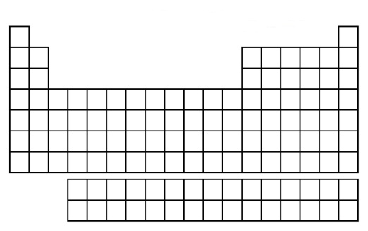  Effective Nuclear Charge | Ionization Energy
Electronegativity | Atomic / Ionic Radius
-10-
Other Trends of the Periodic Table

- Group & Family Names:
Old # | New # | Main Name | Notes
IA | 1 | Alkali Metals | very active metals. "alkali" means from ashes
IIA | 2 | Alkaline Earth Metals | active metals - found in earthen or mineral form.
IIIB-IIB | 3-12 | Transition Metals | collectively called the “d” block elements
IIIA | 13 | Boron Group | a.k.a the icosagens
IVA | 14 | Carbon Group | a.k.a. the crystallogens
VA | 15 | Nitrogen Group | a.k.a. the pnictogens
VIA | 16 | Oxygen Group | a.k.a. the chalcogens
VIIA | 17 | Fluorine Group* | a.k.a. the halogens
VIIIA | 18 | Noble Gases | all discovered by the same person – Sir W. Ramsey
Z=57-70 | N/A | Lanthanides‎§ | named after the first element in the group (Lanthanum)
Z=89-102 | N/A | Actinides§ | named after the first element in the group (Actinium)

*Groups 13-17 can be called by the first element located in the group (i.e. Boron is the first element in Group 13, therefore it is called the Boron Group). However, Group 17 is rarely called the Fluorine Group. It is always referred to by its other name, the Halogen Group.

§ These two groups are collectively known as “f” block elements.

- Valence Electron Trend
- The number of electrons on the outermost energy level
- Trend: (Group 1 = 1; Group 2 = 2; Group 13 = 3; Group 14 = 4; Group 15 = 5; Group16 = 6; Group17 = 7; Group 18 = 8)
- If you look at the Old # of the periodic table. The Roman numeral given is the same number!

- Oxidation Number Trend
- A reflection of the number of electrons an atom must either gain or lose in order to achieve an octet.
- Trend: Group 1 = +1; Group 2 = +2; Group 13 = +3; Group 14 = ±4; Group 15 = -3; Group16 = -2; Group17 = -1; Group 18 = 0 (because it already has an octet).

Let’s take a look at how the trends of valence electron and oxidation number are connected. Draw Bohr diagrams for these elements: 1. Lithium (Li, Z=3) 2. Sodium (Na, Z = 11) 3. Oxygen (O, Z=8) 4. Silicon (Si, Z=14)

